**Ship Hide Documentation**

**Created by**

Nasmeen Islam 6532114921

Paponthanai Aunsopa 6532118421

**2110215 Programming Methodology Semester 2 Year 2022 Chulalongkorn University**

**Ship Hide**

In the middle of the ocean, on a cruise ship You take on the role of Nontanun, a young man who infiltrates the ship to retrieve his sweetheart Nuntacha who has been kidnapped by an anonymous gang of criminals. Several armed thieves in full uniform make up the bunch. So it's not at all simple. Nuntacha can be saved safely by Nontanun. As a result, solving many shipboard puzzles requires expertise, keen thinking, and observation. Including getting rid of many bandits on this ship

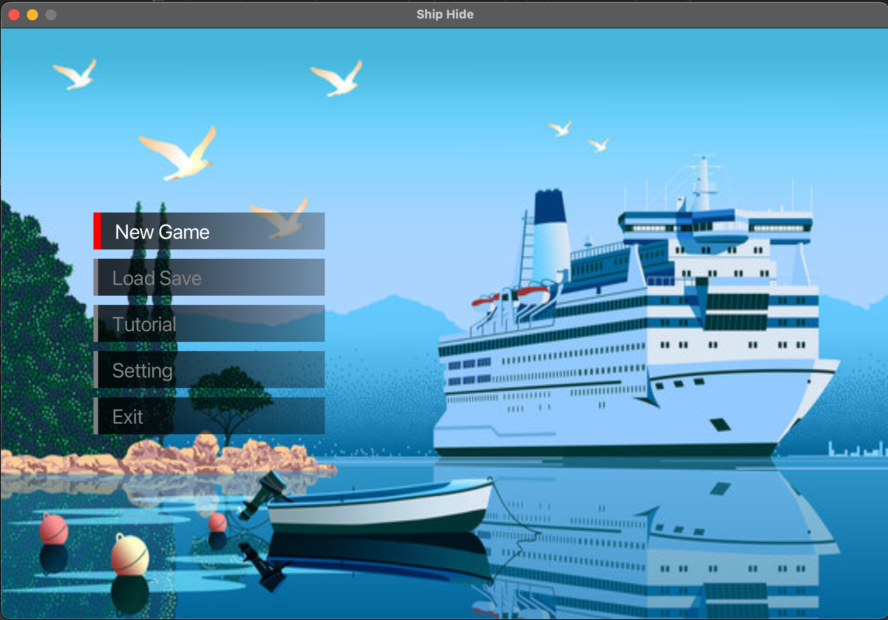

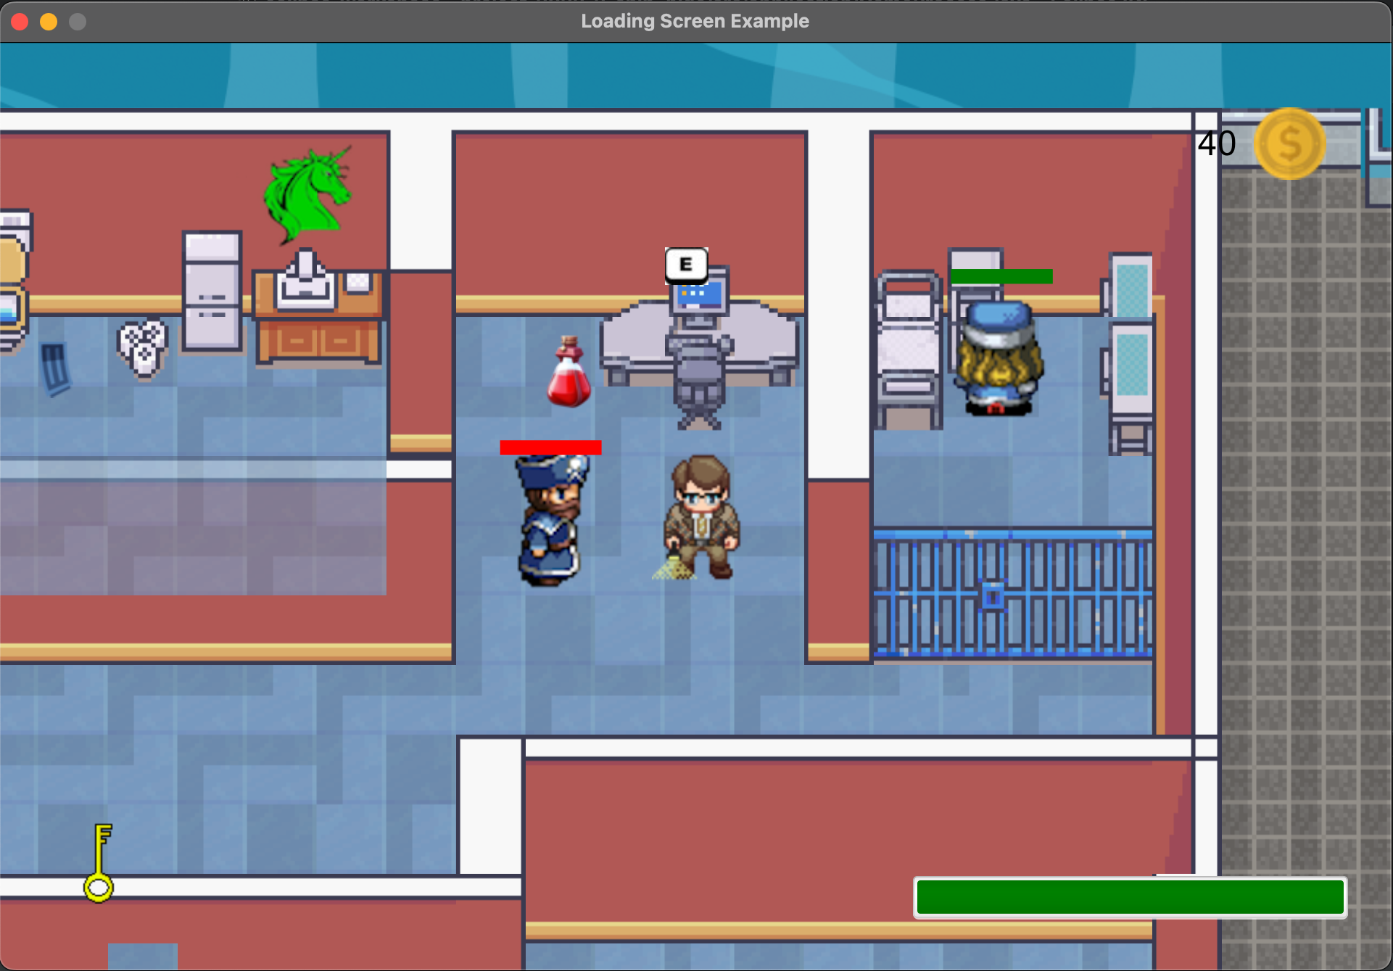

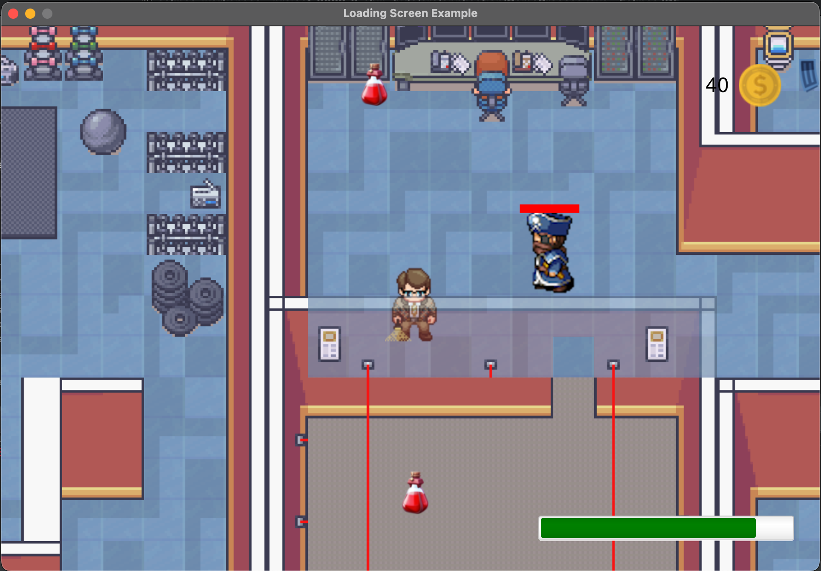

**Tutorial**

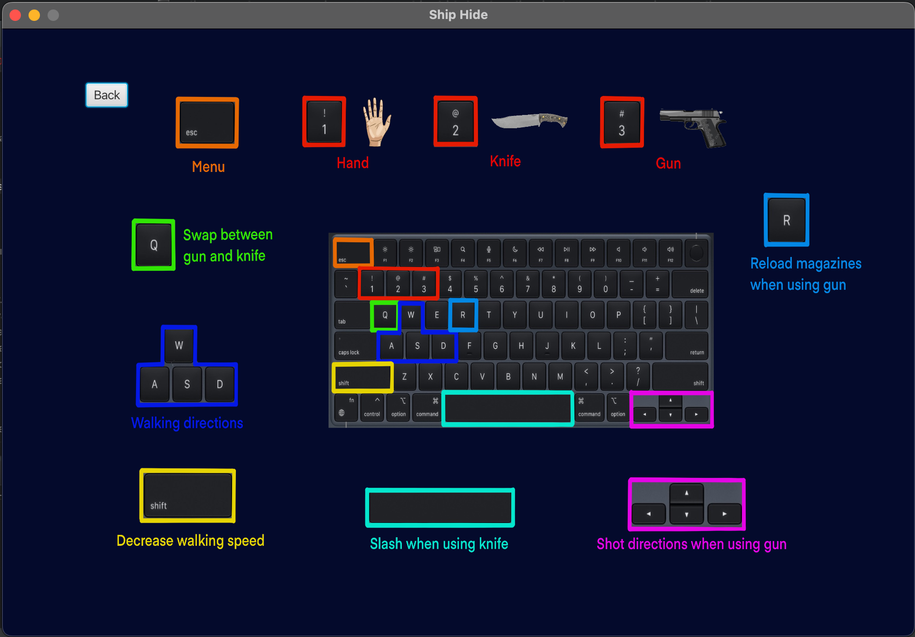

**1. Package logic.base**

1.1 abstract class GameObject implements Serializable

1.1.1 Fields

| # double xPos | Position in the x-axis of GameObject. |
| --- | --- |
| # double yPos | Position in the y-axis of GameObject. |
| # double xVelo | Velocity in the x-axis of GameObject. |
| # double yVelo | Velocity in the y-axis of GameObject. |
| # double xDif | Discrepancy in the x-axis of GameObject. |
| # double yDif | Discrepancy in the y-axis of GameObject. |
| # double w | Width of GameObject. |
| # double h | Height of GameObject. |
| # ID id | Id of GameObject. |
| # int Code | Code of GameObject. |
| # boolean beforeTwo | Position in rendering of GameObject. |
| - final long serialVersionUID | Id for save. |
| - double littleMove | TODO |
| - double count | TODO |
| transient # Rectangle solidArea | Solid Area of GameObject. |

1.1.2 Constructors

| + GameObject(double xPos, double yPos, ID id) | Initialize the GameObject fields with respective values, set xDif, yDif, w, h, xVelo and yVelo to 0, set solidArea with above information, set Code to Handler.Code+1 and set beforeTwo to true, set littleMove to random value between -1 and 1, and set count to 0.05f. |
| --- | --- |
| + GameObject(double xPos, double yPos, ID id ,double xDif ,double yDif ,double w ,double h) | Initialize the GameObject fields with respective values, set xVelo and yVelo to 0, set solidArea with above information, set Code to Handler.Code+1, set beforeTwo to true, set littleMove to random value between -1 and 1, and set count to 0.05f. |

1.1.3 Methods

| + void move() | Set xPos with xPos + yVelo and set yPos with yPos + yVelo. |
| --- | --- |
| + Point getMiddlePoint(Rectangle A) | Return Point that middle position in Rectangle A. |
| + void shift() | Shift objects up and down alternately. |
| + void ShowSolidArea(GraphicsContext gc) | Set fill to pink color and set fill Rectangle |
| + abstract void update() | Do nothing. |
| + abstract void initImg() | Do nothing. |
| + abstract void render(GraphicsContext gc) | Do nothing. |
| getter / setter for GameObject. |  |

1.2 class Handler implements Serializable

1.2.1 Fields

| + int code | Specific code. |
| --- | --- |
| + int progress | Progress of player. |
| + Handler instance | Instance value of Handler. |
| + Player player | Class Player that collects player information. |
| - LinkedList<GameObject> allObjects | Collects all objects in Game. |
| - final long serialVersionUID | Id for save. |

1.2.2 Constructor

| + Handler() | Set Handler.progress to 0 and set Handler.code to 10000. |
| --- | --- |

1.2.3 Methods

| + Handler getInstance() | Initial instance to new Handler and return instance. |
| --- | --- |
| + void replace(Handler handler) | Replace handler with respective handler. |
| + void update() | Update all objects and player. |
| + void render() | Render all objects that are not StableObject and render player. |
| + void renderStable(GraphicsContext gc) | Render all objects that are StableObject. |
| + void updateAfterLoadSave(KeyInput input) | Update every object in Handler. |
| + void addObject(GameObject object)) | Add object to allObject. |
| + void removeObject(GameObject object)) | Remove object in allObject. |
| getter / setter for Handler. |  |

1.3 class Tile extends GameObject

1.3.1 Fields

| - int x | Index of x-axis. |
| --- | --- |
| - int y | Index of y-axis. |
| - int state | State of each Tile. |
| transient - Image image0 | Wall image of each Tile. |
| transient - Image image2 | Superimposed image of each Tile. |
| transient - Image image2_0 | Pale superimposed image of each Tile. |
| - final long serialVersionUID | Id for save. |

1.3.2 Constructor

| + Tile(int xPos, int yPos, ID id ,int x ,int y ,int state) | Using super for initial xPos, yPos and id. Initialize the Tile fields with respective values and initial image. |
| --- | --- |

1.3.3 Methods

| + void initImg() | Set image0 and image2 to null if state equal 1. set image0, image2 and image2_0 to image that in “res folder” with path ( "Maps/project_" + <state> +"/tile_" + x + "_" + y + ".png" ) |
| --- | --- |
| + void update() | Do nothing. |
| + void render(GraphicsContext gc) | Do nothing. |
| getter / setter for Tile. |  |

1.4 class Map implements Serializable

1.4.1 Fields

| - int mapTileNum[][] | State of each tile ( 0 = Wall, 1 = Floor, 2 = Superimposed and 2_0 = Pale superimposed ). |
| --- | --- |
| - Tile mapTile[][] | Tile of each position in map. |
| + Map instance | Instance value of Map. |
| transient - Image map_1 | Image of Floor state. |
| - final long serialVersionUID | Id for save. |

1.4.2 Constructor

| + Map() | Initial Map with values each Tile. |
| --- | --- |

1.4.3 Methods

| + Map getInstance() | Initial instance to new Map and return instance. |
| --- | --- |
| + void replace(Map map) | Replace Map with respective map. |
| + void render_0(GraphicsContext gc, int xTile, int yTile) | Draw an image that is the Wall state in scope that the player can see. |
| + void render_1(GraphicsContext gc) | Draw map_1. |
| + void render_2(GraphicsContext gc, int xTile, int yTile) | Draw an image that is the Superimposed state in scope that the player can see. ( image2_0 if renderState is true and image2 if renderState is false ) |
| + void updateAfterLoadSave() | Initial map_1 and initial all of the images in the map. |
| + void initImg() | Set map_1 to LoadSave.Map_1. |
| getter / setter for Map. |  |

1.5 enum ID

1.5.1 enums

| Map() | Id of Map. |
| --- | --- |
| Tile() | Id of Tile. |
| Player() | Id of Player. |
| Criminal() | Id of Criminal. |
| Commander() | Id of Commander. |
| Captive() | Id of Captive. |
| Block() | Id of MBlockap. |
| Door1() | Id of Door1. |
| Door2() | Id of Door2. |
| DoorJail() | Id of DoorJail. |
| MusiumDoor() | Id of MusiumDoor. |
| Key1() | Id of Key1. |
| Key2() | Id of Key2. |
| PistolGun() | Id of PistolGun. |
| Ak47Gun() | Id of Ak47Gun. |
| PistolMagazine() | Id of PistolMagazine. |
| Ak47Magazine() | Id of Ak47Magazine. |
| Bullet() | Id of Bullet. |
| Knife() | Id of Knife. |
| Slash() | Id of Slash. |
| HpBottle() | Id of HpBottle. |
| Computer() | Id of Computer. |
| Helicopter() | Id of Helicopter. |
| Treder() | Id of Treder. |
| Label1() | Id of Label1. |
| Label2() | Id of Label2. |
| Label3() | Id of Label3. |
| Label4() | Id of Label4. |
| Lazer1() | Id of Lazer1. |
| Lazer2() | Id of Lazer2. |
| Sculpture() | Id of Sculpture. |
| Coin() | Id of Coin. |

1.6 class Keys

1.6.1 Fields

| + boolean Q | Q Button Press Status. |
| --- | --- |
| + boolean W | W Button Press Status. |
| + boolean E | E Button Press Status. |
| + boolean R | R Button Press Status. |
| + boolean T | T Button Press Status. |
| + boolean Y | Y Button Press Status. |
| + boolean U | U Button Press Status. |
| + boolean I | I Button Press Status. |
| + boolean O | O Button Press Status. |
| + boolean P | P Button Press Status. |
| + boolean A | A Button Press Status. |
| + boolean S | S Button Press Status. |
| + boolean D | D Button Press Status. |
| + boolean F | F Button Press Status. |
| + boolean G | G Button Press Status. |
| + boolean H | H Button Press Status. |
| + boolean J | J Button Press Status. |
| + boolean K | K Button Press Status. |
| + boolean L | L Button Press Status. |
| + boolean Z | Z Button Press Status. |
| + boolean X | X Button Press Status. |
| + boolean C | C Button Press Status. |
| + boolean V | V Button Press Status. |
| + boolean B | B Button Press Status. |
| + boolean N | N Button Press Status. |
| + boolean M | M Button Press Status. |
| + boolean SHIFT | SHIFT Button Press Status. |
| + boolean SPACE | SPACE Button Press Status. |
| + boolean LEFT | LEFT Button Press Status. |
| + boolean RIGHT | RIGHT Button Press Status. |
| + boolean UP | UP Button Press Status. |
| + boolean DOWN | DOWN Button Press Status. |
| + boolean ZERO | ZERO Button Press Status. |
| + boolean ONE | ONE Button Press Status. |
| + boolean TWO | TWO Button Press Status. |
| + boolean THREE | THREE Button Press Status. |
| + boolean FOUR | FOUR Button Press Status. |
| + boolean FIVE | FIVE Button Press Status. |
| + boolean SIX | SIX Button Press Status. |
| + boolean SEVEN | SEVEN Button Press Status. |
| + boolean EIGHT | EIGHT Button Press Status. |
| + boolean NINE | NINE Button Press Status. |
| + boolean ESC | ESC Button Press Status. |

1.6.2 Constructor

| + Keys() | Set all of the fields to false. |
| --- | --- |

1.7 class KeyInput implements Serializable

1.7.1 Fields

| + Keys key | Key |
| --- | --- |
| - final long serialVersionUID | Id for save. |

1.7.2 Constructor

| + KeyInput() | Initialize key to new Keys. |
| --- | --- |

1.7.3 Methods

| + void keyPressed(KeyEvent x) | Key press. |
| --- | --- |
| + void keyReleased(KeyEvent x) | Key Released. |
| + void setFalse() | Set all of the key to false |

1.8 interface Attackable

1.8.1 Methods

| + int damage() | Do nothing. |
| --- | --- |
| + int dps_damage() | Do nothing. |

1.9 interface StableObject

1.8.1 Methods

| + void interact(Player player) | Do nothing. |
| --- | --- |

**2. Package logic.container**

2.1 class KeyLocker extends GameObject implements StableObject

2.1.1 Fields

| - boolean picked | State of picking of KeyLocker. |
| --- | --- |
| transient - Image image | Image of KeyLocker |
| - final long serialVersionUID | Id for save. |

2.1.2 Constructor

| + KeyLocker(int xPos, int yPos, ID id) | Using super for initial xPos, yPos, id, xDif = -10, yDif = -10, w = 60 and h = 90. Initialize image. |
| --- | --- |

2.1.3 Methods

| + void initImg() | Set image with path LoadSave.KEY1 if Id is Key1 and set image with path LoadSave.KEY2 if Id is Key2. |
| --- | --- |
| + void update() | Shift object with method of GameObject. |
| + void render() | Render image if KeyLocker is not picked by player. |
| + void interact(Player player) | Play Pick’s sound, set picked to true, add KeyLocker to the bag of player, remove KeyLocker from allObject of Handler and save the game. |
| getter / setter for KeyLocker. |  |

2.2 class HpBottle

2.2.1 Fields

| - int efficiency | Efficiency of HpBottle. |
| --- | --- |
| - boolean picked | State of picking of HpBottle. |
| transient - Image image | Image of HpBottle. |
| - final long serialVersionUID | Id for save. |

2.2.2 Constructor

| + HpBottle(double xPos, double yPos, ID id) | Using super for initial xPos, yPos, id, xDif = 10, yDif = 10, w = 50 and h = 60.  Set picked to false, initial image, set efficiency to 1000 if game is in the Detective mode and set efficiency to 10000 if game is in the Desperate  mode |
| --- | --- |

2.2.3 Methods

| + void initImg() | Set image with path LoadSave.HPBOTTLE. |
| --- | --- |
| + void update() | Shift object with method of GameObject. |
| + void render() | Render image. |
| + void interact(Player player) | Play Pick’s sound, set picked to true, increase the player’s Hp equal efficiency of HpBottle and remove KeyLocker from allObject of Handler. |
| getter / setter for KeyLocker. |  |

2.3 class Knife extends GameObject implements Attackale, StableObject

2.3.1 Fields

| - int damage | Damage of knife. |
| --- | --- |
| - boolean picked | State of picking a Knife. |
| - boolean visible | Visibility of Knife. |
| transient - Image image | Image of knife. |
| transient - Image imageUsed | Image of knife when player holds knife. |
| - final long serialVersionUID | Id for save. |

2.3.2 Constructor

| + Knife(double xPos, double yPos, ID id) | Using super for initial xPos, yPos, id, xDif = 0, yDif = 0, w = 100 and h = 50.  Set picked to false, set visible to false and initial image. |
| --- | --- |
| + Knife(double xPos, double yPos, ID id, boolean visible) | Using super for initial xPos, yPos, id, xDif = 0, yDif = 0, w = 100 and h = 50.  Set picked to false, set visible with respective value and initial image. |

2.2.3 Methods

| + void initImg() | Set image with path LoadSave.KNIFE and set imageUsed with path LoadSave.KNIFE _USED. |
| --- | --- |
| + void update() | Remove knife from allObject of Handler if knife is not visible and shift object with method of GameObject. |
| + void render() | Render image if knife is visible. |
| + void interact(Player player) | Play Pick’s sound, set picked to true, add knife to player’s bag, set knife of player to true and remove KeyLocker from allObject of Handler. |
| + int damage() | Return damage of knife. |
| + int dps_damage() | Return 0 |
| getter / setter for KeyLocker. |  |

2.4 class Bullet extends GameObject implements Attackale

2.4.1 Fields

| - int maxDamage | Maximum Damage of Bullet. |
| --- | --- |
| - int minDamage | Minimum Damage of Bullet. |
| - ID owner | ID of owner. |
| - final long serialVersionUID | Id for save. |

2.4.2 Constructor

| + Bullet(double xPos, double yPos, ID id) | Using super for initial xPos, yPos, id, xDif = 7, yDif = 3, w = 16 and h = 16.  Set xVelo to 0, set yVelo to 0 and set minimum and maximum damage to 30 and 50. |
| --- | --- |
| + Bullet(double xPos, double yPos, ID id, double xVelo, double yVelo) | Using super for initial xPos, yPos, id, xDif = 7, yDif = 3, w = 16 and h = 16. Set minimum and maximum damage to 30 and 50. and set xVelo and yVelo with respective values. |
| + Bullet(double xPos, double yPos, ID id, double xVelo, double yVelo, int MxD, int MnD) | Using super for initial xPos, yPos, id, xDif = 7, yDif = 3, w = 16 and h = 16. Set variables with respective values. |
| + Bullet(double xPos, double yPos, ID id, int MxD, int MnD) | Using super for initial xPos, yPos, id, xDif = 7, yDif = 3, w = 16 and h = 16.  Set minimum and maximum damage with respective values. |

2.4.3 Methods

| + void initImg() | Do nothing. |
| --- | --- |
| + void update() | Update object. |
| + void render() | Render object. |
| + int damage() | Return random damage between maxDamage and minDamage. |
| + int dps_damage() | Return 0 |
| getter / setter for KeyLocker. |  |

2.5 class Magazine extends GameObject implements StableObject

2.5.1 Fields

| # int numMaxBullet | Number maximum bullet in Magazine. |
| --- | --- |
| # boolean picked | State of picking a Magazine. |
| # boolean visible | Visibility of Magazine. |
| # ArrayList<Bullet> magazine | All of Bullet in magazine. |
| transient - Image image | Image of Magazine. |
| - final long serialVersionUID | Id for save. |

2.5.2 Constructor

| + Magazine(double xPos, double yPos, ID id, int numBullet) | Using super for initial xPos, yPos, id, xDif = -10, yDif = -10, w = 50 and h = 50.  Set picked to false, set visible to false, initial image, set numMaxBullet to numBullet, set free magazine and add Bullet to magazine equal numBullet. |
| --- | --- |

2.5.3 Methods

| + void initImg() | Set image with path LoadSave.MAGAZINE |
| --- | --- |
| + void update() | Shift object with method of GameObject. |
| + void render() | Render image if magazine is visible. |
| + void interact(Player player) | Do nothing if the magazine is not visible. Otherwise play Pick’s sound, set picked to true, add magazine to player’s bag and remove magazine from allObject of Handler. |
| + void addBullet(Bullet bullet) | Add a bullet in the magazine. |
| + void addBulletsPack(int count) | Add bullets equal to count in the magazine. |
| + void reduceBullet() | Remove one bullet in the magazine. |
| getter / setter for KeyLocker. |  |

2.6 class Gun extends GameObject

2.5.1 Fields

| # boolean picked | State of picking a Gun. |
| --- | --- |
| # boolean visible | Visibility of Gun. |
| transient - Image image | Image of Gun. |
| transient - Image imageUsed | Image of Gun when player holds Gun. |
| - final long serialVersionUID | Id for save. |

2.5.2 Constructor

| + Magazine(double xPos, double yPos, ID id, boolean picked, boolean visible) | Using super for initial xPos, yPos, id.  and set variables with respective values. |
| --- | --- |
| + Magazine(double xPos, double yPos, ID id, double xDif ,double yDif ,double w ,double h, boolean picked, boolean visible) | Using super for initializing and set variables with respective values. |

2.5.3 Methods

| + void update() | Shift object with method of GameObject. |
| --- | --- |
| + void render() | Render image if gun is visible. |
| + void interact(Player player) | Play Pick’s sound, set picked to true, add gun to player’s bag, set player’s gun to true and remove gun from allObject of Handler. |
| + void shoot(int xPos, int yPos, String direct, ID owner) | Shoot bullet. |
| + abstract void shoot(int xPos, int yPos, String direct, ID owner) | Do nothing. |
| + abstract void initImg() | Do nothing. |
| + abstract void reduceBullet() | Do nothing. |
| + abstract int getNumMagazine() | Do nothing. |
| + abstract boolean shootAble() | Do nothing. |
| + abstract boolean reload() | Do nothing. |
| + abstract Bullet getBullet() | Do nothing. |
| getter / setter for KeyLocker. |  |

**3. Package logic.container.ak47**

3.1 class Ak47Gun extends Gun implements AttackAble, StableObject

3.1.1 Fields

| - int price | Price of Ak47. |
| --- | --- |
| - String name | Name of Ak47. |
| - Ak47Magazine magazine | Magazine of Ak47. |
| - final long serialVersionUID | Id for save. |

3.1.2 Constructor

| + Ak47Gun(int xPos, int yPos, ID id) | Using super for initial xPos, yPos, id, xDif = -10, yDif = -10, w = 120, h = 70, picked = false and visible = false. Set name to “Ak-47”, price to 15, initialize image and set of magazine with a number of 30. |
| --- | --- |
| + Ak47Gun(int xPos, int yPos, ID id, int bulletNum) | Using super for initial xPos, yPos, id, xDif = -10, yDif = -10, w = 120, h = 70, picked = false and visible = false. Set name to “Ak-47”, price to 15, initialize image and set of magazine with a number of bulletNum. |
| + Ak47Gun(int xPos, int yPos, ID id, boolean visible) | Using super for initial xPos, yPos, id, xDif = -10, yDif = -10, w = 120, h = 70, picked = false and visible = visible. Set name to “Ak-47”, price to 15, initialize image and set of magazine with a number of 30. |

3.1.3 Methods

| + void initImg() | Set image with path LoadSave.AK47and set imageUsed with path LoadSave.AK47_USED. |
| --- | --- |
| + boolean shootAble() | If there is no magazine in the gun or there is no bullet in the magazine then return false. Otherwise return true |
| + boolean reload() | Reload a gun. |
| + int damage() | If shootAble then return damage of the first bullet in the magazine. |
| + void reduceBullet() | If a magazine has a bullet then reduce the bullet in the magazine. |
| + Bullet getBullet() | Return first Bullet in Magazine. |
| + int dps_damage() | Return 0 |
| + int getNumMagazine() | Return number of Ak 47 Magazine in player’s bag. |
| getter / setter for KeyLocker. |  |

3.2 class Ak47Magazine extends Magazine implements StableObject

3.2.1 Fields

| - int price | Price of Ak47 magazine.. |
| --- | --- |
| - String name | Name of Ak47 magazine. |
| - final long serialVersionUID | Id for save. |

3.2.2 Constructor

| + Ak47Magazine(int xPos, int yPos, ID id) | Using super for initial xPos, yPos, id and numbullet = 30. Set name to “Ak-47 Magazine” and price to 5. |
| --- | --- |
| + Ak47Magazine(int xPos, int yPos, ID id, int bulletNum) | Using super for initial xPos, yPos, id and numbullet. Set name to “Ak-47 Magazine” and price to 5. |

3.2.3 Methods

| getter / setter for Ak47 Magazine.. |  |
| --- | --- |

**4. Package logic.container.pistol**

4.1 class PistolGun extends Gun implements AttackAble, StableObject

4.1.1 Fields

| - PistolMagazine magazine | Magazine of Pistol. |
| --- | --- |
| - final long serialVersionUID | Id for save. |

4.1.2 Constructor

| + PistolGun(int xPos, int yPos, ID id) | Using super for initial xPos, yPos, id, xDif = -10, yDif = -10, w = 120, h = 70, picked = false and visible = false. Initialize image and set of magazines with a number of 6. |
| --- | --- |
| + PistolGun(int xPos, int yPos, ID id, int bulletNum) | Using super for initial xPos, yPos, id, xDif = -10, yDif = -10, w = 120, h = 70, picked = false and visible = false. Initialize image and set magazine.. |
| + PistolGun(int xPos, int yPos, ID id, boolean visible) | Using super for initial xPos, yPos, id, xDif = -10, yDif = -10, w = 120, h = 70, picked = false and visible. Initialize image and set of magazines with a number of 6. |

4.1.3 Methods

| + void initImg() | Set image with path LoadSave.Gun and set imageUsed with path LoadSave.GUN_USED. |
| --- | --- |
| + boolean shootAble() | If there is no magazine in the gun or there is no bullet in the magazine then return false. Otherwise return true |
| + boolean reload() | Reload a gun. |
| + int damage() | If shootAble then return damage of the first bullet in the magazine. |
| + void reduceBullet() | If a magazine has a bullet then reduce the bullet in the magazine. |
| + Bullet getBullet() | Return first Bullet in Magazine. |
| + int dps_damage() | Return 0 |
| + int getNumMagazine() | Return number of Pistol Magazine in player’s bag. |
| getter / setter for KeyLocker. |  |

4.2 class PistolMagazine extends Magazine implements StableObject

4.2.1 Fields

| - final long serialVersionUID | Id for save. |
| --- | --- |

4.2.2 Constructor

| + PistolMagazine(int xPos, int yPos, ID id) | Using super for initial xPos, yPos, id and numbullet = 6. Set visible to true. |
| --- | --- |
| + PistolMagazine(int xPos, int yPos, ID id, int bulletNum) | Using super for initial xPos, yPos, id and numbullet. Set visible to true. |

4.2.3 Methods

| getter / setter for Pistol Magazine.. |  |
| --- | --- |

**5. Package logic.person**

5.1 abstract class Person extends GameObject

5.1.1 Fields

| # int hp | Hp of Person. |
| --- | --- |
| # int hpMax | Hp maximum of Person. |
| # int used | Indicates the type of weapon being carried. ( 1 = Hane, 2 = Knife, 3 = Pistol, 4 = Ak47 ) |
| # int preUsed | Indicates the type of weapon being carried before “used”. |
| # int spriteCnt | Sprite for animation. |
| # int bulletTime | Cooldown of shooting guns. |
| # int knifeTime | Cooldown of slashing knives. |
| # int reloadTime | Cooldown of reloading guns. |
| # int randWalkTime | Cooldown of random walking. |
| # int chasingTime | Chasing time of Person. |
| # int interval | Interval for animation. |
| # boolean knife | State of having a knife. |
| # boolean gun | State of having a gun. |
| # boolean chasing | State of chasing. |
| # String direct | Current direction of Person. |
| # String prv_direct | Previous direction of Person. |
| transient # Rectangle footArea | Foot area of Person. |
| transient # Rectangle renderArea | Render area of Person. |
| + PathFinder pathFinder | PathFinder algorithm used for chasing a Person. |
| - int direction | Direction of Person. |
| - int[][] mapTileNum | Value of every tile in map. |

5.1.2 Constructor

| + Person(double xPos, double yPos, ID id ,double xDif ,double yDif ,double w ,double h) | - Using super for initializing.  - Set footArea with Rectangle(xPos+xDif, yPos+yDif+h-10, w, 10.  - Set renderArea with Rectangle([xPos+xDif, yPos+yDif+40, w, h-40](https://www.google.com/search?client=safari&rls=en&q=xPos+%2B+xDif%2C+yPos+%2B+yDif+%2B+40%2C+w%2C+h+-+40&ie=UTF-8&oe=UTF-8)).  - Set used to 1.  - Set prvUsed to 1.  - Set direct to “Z”.  - Set pre_direct to “Z”  - Set hp to 100.  - Set knife to false.  - Set gun to false.  - Set spriteCnt to 0.  - Set bulletTime to 0.  - Set knifeTime to 0.  - Set reloadTime to 0.  - Set randomWal to 0.  - Set chasingTime to 300.  - Set chasing to false.  - Set interval to 0. |
| --- | --- |

5.1.3 Methods

| + void searchPath(int endRow, int endCol) | Search path to walk. |
| --- | --- |
| + void showPath() | Show path walk. |
| + boolean gunAvailable() | Return gun. |
| + boolean knifeAvailable() | Return knife. |
| + void move() | Move with xVelo and yVelo. |
| + void moveX() | Move with xVelo. |
| + void moveY() | Move with yVelo. |
| + void movePass(double xVelo, double yVelo) | Move pass. |
| + void moveLeft() | Using the movePass method to move with the - absolute value of xVelo and set it directly to “L”. |
| + void moveRight() | Using the movePass method to move with the absolute value of xVelo and set it directly to “R”. |
| + void moveUP() | Using the movePass method to move with the - absolute value of yVelo and set it directly to “U”. |
| + void moveDown() | Using the movePass method to move with the absolute value of yVelo and set it directly to “D”. |
| + void randomWalk() | Random walk. |
| + void showFootArea() | Draw foot area. |
| + abstract void update() | Do nothing. |
| + abstract void render(GraphicsContext gc) | Do nothing |
| + abstract void shoot() | Do nothing |
| + abstract void slash() | Do nothing |
| + abstract void animation() | Do nothing |
| + abstract void setAllArea() | Do nothing |
| getter / setter of Person. |  |

5.2 class Player extends Person

5.2.1 Fields

| - int coin | Coin of Player. |
| --- | --- |
| - final int defaultAni | Default animation of Player set to 9. |
| - double ac | Acceleration in x-axis. |
| - double dc | Acceleration in y-axis. |
| - private boolean swapped | State swapping between each weapon. |
| - private boolean forceStop | Walking permission status. |
| - ArrayList<GameObject> bag | Bag of player. |
| - double curxPos | Position for camera. |
| - double curyPos | Position for camera. |
| transient - Keys key | Key of Player |
| transient - KeyInput input | Input of Player. |
| transient - Image[] T_Up | List of images for up direction. |
| transient - Image[] T_Down | List of images for down direction. |
| transient - Image[] T_Left | List of images for left direction. |
| transient - Image[] T_Right | List of images for right direction. |
| transient - Image currentAni | Current image for animation. |
| transient - Image previousAni | Previous image for animation. |
| - final long serialVersionUID | Id for save. |

5.2.2 Constructor

| + Player(double xPos, double yPos, ID id, KeyInput input) | - Using super for initial xPos, yPos, id, xDif = 10, yDif = 5, w = P_WIDTH, h = P_HEIGHT.  - Initialize the Player with the provided variables.  - Set coin to 40.  - Set ac to 0.8f.  - Set dc to 0.4f..  - Initial image.  - Set swapped to false.  - Set forceStop to false.  - Set direct to “U”.  - Set prv_direct to “Z”.  - Set new Key.  - Set new bag.  - If mode game is Detective then set hpMax to 5,000 otherwise set hpMax to 50,000.  - Set hp to hpMax. |
| --- | --- |

5.2.3 Methods

| + void initImg() | Initiali all image of Player. |
| --- | --- |
| + void update() | Update player. |
| + void walk() | Walk. |
| + void shoot() | Shoot a bullet. |
| + void slash() | Slash knife. |
| + void cut(double val, double low, double high ) | If val > high then return high. if val < low then return low. Otherwise return val. |
| + void render(GraphicsContext gc) | Draw current animation. |
| + void animation | Custom animation. |
| + void walkAni(int frame) | Check direct of player to set correct currentAni. |
| + void setAllArea() | - Set solid area to Ractangle(xPos+10, yPos+5, P_WIDTH, P_HEIGHT)  - Set foot area to Ractangle(xPos+xDif, yPos+yDif+P_HEIGHT-10, w, 10)  - Set render area to Ractangle(xPos+xDif, yPos+yDif+40, w, h-40) |
| + void addItemInBag(GameObject object) | Add object in the player's bag. |
| + void setAcDc(double ac, double dc) | Set new ac and dc values. |
| getter & Setter of Player. |  |

5.3 class Criminal extends Person

5.2.1 Fields

| - PistolGun gun | Gun of Criminal. |
| --- | --- |
| - final int defaultAni | Default animation of Criminal set to 0. |
| transient - Image[] T_Up | List of images for up direction. |
| transient - Image[] T_Down | List of images for down direction. |
| transient - Image[] T_Left | List of images for left direction. |
| transient - Image[] T_Right | List of images for right direction. |
| transient - Image currentAni | Current image for animation. |
| transient - Image previousAni | Previous image for animation. |
| - final long serialVersionUID | Id for save. |

5.3.2 Constructor

| + Criminal(double xPos, double yPos, ID id, double xVelo, double yVelo) | - Using super for initial xPos, yPos, id, xDif = 10, yDif = 5, w = P_WIDTH, h = P_HEIGHT.  - Initialize the Criminal with the provided variables.  - Set hp to 1,000.  - Set direct with xVelo and yVelo.  - Initial gun.  - Initial image. |
| --- | --- |

5.3.3 Methods

| + void initImg() | Initial image of Criminal. |
| --- | --- |
| + void initGun() | Initial PistolGun of Criminal ( numBullet = 10,000 ), set gun to true and set used to 3. |
| + void update() | Update Criminal. |
| + void shoot() | Shoot bullet. |
| + void slash() | Salsh knife. |
| + void cut(double val, double low, double high ) | If val > high then return high. if val < low then return low. Otherwise return val. |
| + void render(GraphicsContext gc) | Draw current animation. |
| + void animation | Custom animation. |
| + void walkAni(int frame) | Check direct of player to set correct currentAni. |
| + void setAllArea() | - Set solid area to Ractangle(xPos+xDif, yPos+yDif, w, h)  - Set foot area to Ractangle(xPos+xDif, yPos+yDif+P_HEIGHT-10, w, 10)  - Set render area to Ractangle(xPos+xDif, yPos+yDif+40, w, h-40) |
| getter & Setter of Player. |  |

5.3 class Commander extends Person

5.3.1 Fields

| - PistolGun gun | Gun of Commander. |
| --- | --- |
| - int gunMod | Frequency of gun. |
| - final int defaultAni | Default animation of Commander set to 0. |
| transient - Image[] T_Up | List of images for up direction. |
| transient - Image[] T_Down | List of images for down direction. |
| transient - Image[] T_Left | List of images for left direction. |
| transient - Image[] T_Right | List of images for right direction. |
| transient - Image currentAni | Current image for animation. |
| transient - Image previousAni | Previous image for animation. |
| - final long serialVersionUID | Id for save. |

5.3.2 Constructor

| + Commander(double xPos, double yPos, ID id, double xVelo, double yVelo) | - Using super for initial xPos, yPos, id, xDif = 10, yDif = 5, w = P_WIDTH, h = P_HEIGHT.  - Initialize the Commander with the provided variables.  - Set hp to 5,000.  - Set gunMod to 5.  - Set direct with xVelo and yVelo.  - Initial gun.  - Initial image. |
| --- | --- |

5.3.3 Methods

| + void initImg() | Initial image of Commander. |
| --- | --- |
| + void initGun() | Initial PistolGun of Commander ( numBullet = 10,000 ), set gun to true and set used to 3. |
| + void update() | Update Commander. |
| + void shoot() | Shoot bullet. |
| + void slash() | slash knife. |
| + void render(GraphicsContext gc) | Draw current animation. |
| + void animation | Custom animation. |
| + void walkAni(int frame) | Check direct of player to set correct currentAni. |
| + void setAllArea() | - Set solid area to Ractangle(xPos+xDif, yPos+yDif, w, h)  - Set foot area to Ractangle(xPos+xDif, yPos+yDif+P_HEIGHT-10, w, 10)  - Set render area to Ractangle(xPos+xDif, yPos+yDif+40, w, h-40) |
| getter & Setter of Player. |  |

5.4 class Captive extends Person

5.2.1 Fields

| - boolean ready | State indicates permission to finish the game. |
| --- | --- |
| - final int defaultAni | Default animation of Criminal set to 9. |
| transient - Image[] T_Up | List of images for up direction. |
| transient - Image[] T_Down | List of images for down direction. |
| transient - Image[] T_Left | List of images for left direction. |
| transient - Image[] T_Right | List of images for right direction. |
| transient - Image currentAni | Current image for animation. |
| transient - Image previousAni | Previous image for animation. |
| - final long serialVersionUID | Id for save. |

5.3.2 Constructor

| + Captive(double xPos, double yPos, ID id, double xVelo, double yVelo) | - Using super for initial xPos, yPos, id, xDif = 10, yDif = 5, w = P_WIDTH, h = P_HEIGHT.  - Initialize the Criminal with the provided variables.  - Set hp to 3,000.  - Set direct with xVelo and yVelo.  - Initial image. |
| --- | --- |

5.3.3 Methods

| + void initImg() | Initial image of Criminal. |
| --- | --- |
| + void initGun() | Initial PistolGun of Criminal ( numBullet = 10,000 ), set gun to true and set used to 3. |
| + void update() | Update Captive. |
| + void shoot() | Do nothing. |
| + void slash() | Do nothing. |
| + void render(GraphicsContext gc) | Draw current animation. |
| + void animation | Custom animation. |
| + void walkAni(int frame) | Check direct of player to set correct currentAni. |
| + void setAllArea() | - Set solid area to Ractangle(xPos+xDif, yPos+yDif, w, h)  - Set foot area to Ractangle(xPos+xDif, yPos+yDif+P_HEIGHT-10, w-10, 10)  - Set render area to Ractangle(xPos+xDif, yPos+yDif+40, w, h-40) |
| getter & Setter of Player. |  |

**6. Package object**

6.1 class Coin extends GameObject implements StableObject

6.1.1 Fields

| transient - Image image | Image of Coin. |
| --- | --- |
| - final long serialVersionUID | Id for save. |

6.1.2 Constructor

| + Coin(double xPos, double yPos, ID id) | Using super for initial xPos, yPos, id, xDif = 0, yDif = 10, w = 35, h = 35 and Initial image. |
| --- | --- |

6.1.3 Methods

| + void initImg() | Initial image of Coin. |
| --- | --- |
| + void update() | Shift object with method of GameObject. |
| + void interact(Player player) | Play GetCoin sound, increase one player’s coin and remove coin from allObject of Handler. |
| + void render(GraphicsContext gc) | Draw image. |
| getter & Setter of Player. |  |

6.2 class Label extends GameObject implements StableObject

6.2.1 Fields

| - boolean interacted | Interact state. |
| --- | --- |
| transient - Image imageInteract | Image interaction of Coin. |
| transient - Image imagePuzzle | Puzzle Image of Coin. |
| - final long serialVersionUID | Id for save. |

6.2.2 Constructor

| + Label(double xPos, double yPos, ID id) | Using super for initial xPos, yPos, id, xDif = -30, yDif = 10, w = 130, h = 90, set interacted to false and Initial image. |
| --- | --- |

6.2.3 Methods

| + void initImg() | Initial image of Label. |
| --- | --- |
| + void update() | If distance between label and player less than 4*TILESIZE then sets the interaction to true. Otherwise sets the interaction to false. |
| + void interact(Player player) | If Obj.press is false then  - Set time to 0.  - Set pressed to true.  - Set Obj.temp1 to the player's ac.  - Set Obj.temp2 to the player's dc.  - Set ac and dc of the player to 0.  - Set player’s forceStop to true.  - Add image in GameProcess’s root.  Otherwise then  - Set time to 0.  - Set pressed to false.  - Set ac and dc of the player to Obj.temp1 and Obj.temp2.  - Set player’s forceStop to false.  - Remove image in GameProcess’s root. |
| + void render(GraphicsContext gc) | If the Label is interacted with, draw an image. |
| getter & Setter of Player. |  |

6.3 class Trader extends GameObject implements StableObject

6.3.1 Fields

| - boolean interacted | Interact state. |
| --- | --- |
| transient - Image image | Image of Trader. |
| - final long serialVersionUID | Id for save. |

6.3.2 Constructor

| + Trader(double xPos, double yPos, ID id) | Using super for initial xPos, yPos, id, xDif = -30, yDif = 10, w = 130, h = 90, set interacted to false and Initial image. |
| --- | --- |

6.3.3 Methods

| + void initImg() | Initial image of Trader. |
| --- | --- |
| + void update() | If distance between label and player less than 4*TILESIZE then sets the interaction to true. Otherwise sets the interaction to false. |
| + void interact(Player player) | Set gameState in GameProcess to PAUSE_STATE and set scene in GameProcess to Shop’s scene. |
| + void render(GraphicsContext gc) | If the Trader is interacted with, draw an image. |
| getter & Setter of Player. |  |

6.4 class Helicopter extends GameObject implements StableObject

6.4.1 Fields

| - boolean interacted | Interact state. |
| --- | --- |
| transient - Image image | Image of Helicopter. |
| - final long serialVersionUID | Id for save. |

6.4.2 Constructor

| + Helicopter(double xPos, double yPos, ID id) | Using super for initial xPos, yPos, id, xDif = -50, yDif = 0, w = 300, h = 150, set interacted to false and Initial image. |
| --- | --- |

6.4.3 Methods

| + void initImg() | Initial image of Helicopter.. |
| --- | --- |
| + void update() | If distance between label and player less than 4*TILESIZE then sets the interaction to true. Otherwise sets the interaction to false. |
| + void interact(Player player) | If Captive is not ready then do nothing.  Otherwise  - Stop music  - Play gameComplete music  - Set gameState in GameProcess to GAME_COMPLETE_STATE.  - Set scene in GameProcess to GameComplete’s scene. |
| + void render(GraphicsContext gc) | If the Helicopter is interacted with, draw an image. |
| getter & Setter of Player. |  |

6.5 class Computer extends GameObject implements StableObject

6.5.1 Fields

| - boolean interacted | Interact state. |
| --- | --- |
| - boolean saved | Save state. |
| transient private - imageInteract | Image Interact of Computer. |
| - final long serialVersionUID | Id for save. |

6.5.2 Constructor

| + Computer(double xPos, double yPos, ID id) | Using super for initial xPos, yPos, id, xDif = -50, yDif = 0, w = 150, h = 150, set interact to false, set saved to false and Initial image. |
| --- | --- |

6.5.3 Methods

| + void initImg() | Initial image of Computer. |
| --- | --- |
| + void update() | If distance between label and player less than 4*TILESIZE then sets the interaction to true. Otherwise sets the interaction to false. |
| + void interact(Player player) | If saved is false then save in GameProcess.  - Set Obj.temp1 to the player's ac.  - Set Obj.temp2 to the player's dc.  - Set ac and dc of the player to 0.  - Set player’s forceStop to true.  - Add PasswordPopUp in the root of GameProcess. |
| + void render(GraphicsContext gc) | If the Computer is interacted with, draw an image. |
| getter & Setter of Player. |  |

6.6 class Door extends GameObject implements StableObject

6.6.1 Fields

| - ID KeyId | KeyId of door. |
| --- | --- |
| - int doorCount | Time to open or close the door. |
| - boolean opened | open state. |
| transient - Image imageOpen | Open Image of door. |
| transient - Image imageClose | Close Image of door. |
| - final long serialVersionUID | Id for save. |

6.6.2 Constructor

| + Door(double xPos, double yPos, ID id) | - Using super for initial xPos, yPos and id.  - Set keyID.  - Set id.  - Set opened to false.  - Set doorCount to 0.  - Initial image.  If the the door has id as DOOR1 then  - Set xDif = -50, yDif = 0, w = 150,h =130  - Set solidArea to Rectangle(xPos+xDif ,yPos+yDif, w, h  If the the door has id as DOOR2 then  - Set xDif = -50, yDif = -10, w = 110,h =150  - Set solidArea to Rectangle(xPos+xDif ,yPos+yDif, w, h |
| --- | --- |

6.6.3 Methods

| + void initImg() | Initial image of Door. |
| --- | --- |
| + void update() | Update door. |
| + void interact(Player player) | Interact with players. |
| + void render(GraphicsContext gc) | If the door is open then draw imageOpen. Otherwise draw imageClose. |
| getter & Setter of Player. |  |

6.7 class DoorJail extends GameObject implements StableObject

6.7.1 Fields

| + boolean opened | Open state. |
| --- | --- |
| transient - Image imageOpen | Open Image of door. |
| transient - Image imageClose | Close Image of door. |
| - final long serialVersionUID | Id for save. |

6.7.2 Constructor

| + DoorJail(double xPos, double yPos, ID id) | - Using super for initial xPos, yPos, id, 0, 0, P_WIDTH, P_HEIGHT.  - Set opened to false.  - Initial image. |
| --- | --- |

6.7.3 Methods

| + void initImg() | Initial image of DoorJail. |
| --- | --- |
| + void update() | Update doorJail. |
| + void interact(Player player) | Interact with a player. |
| + void render(GraphicsContext gc) | If the door is open then draw imageOpen. Otherwise draw imageClose. |
| getter & Setter of Player. |  |

6.8 class MusiumDoor extends GameObject implements StableObject

6.8.1 Fields

| - int[][] password | Password of opening museum door. |
| --- | --- |
| - boolean opened | Open state. |
| - boolean saved | Save state. |
| - Sculpture[] sculpture | List of sculpture. |
| transient - Image imageOpen | Open Image of door. |
| transient - Image imageClose | Close Image of door. |
| - final long serialVersionUID | Id for save. |

6.8.2 Constructor

| + MusiumDoor(double xPos, double yPos, ID id, Sculpture[] sculpture  ) | - Using super for initial xPos, yPos, id, 0, 10, 100, 100.  - Set opened to false.  - Set saved to false.  - Set sculpture.  - Initial image.  - Initial password. |
| --- | --- |

6.8.3 Methods

| + void initImg() | Initial image of DoorJail. |
| --- | --- |
| + void update() | If every sculpture is a correct location from password then open the museum door and save in GameProcess. |
| + void interact(Player player) | Interact with a player. |
| + void render(GraphicsContext gc) | If the door is open then draw imageOpen. Otherwise draw imageClose. |
| + void initPassword() | Initialize password with the following value :  (68 ,46), (52,40), (72, 41), (58, 42) |
| getter & Setter of Player. |  |

6.9 class Sculpture extends GameObject implements StableObject

6.9.1 Fields

| transient - Image image | Image of sculpture. |
| --- | --- |
| - final long serialVersionUID | Id for save. |

6.9.2 Constructor

| + Sculpture(double xPos, double yPos, ID id) | - Using super for initial xPos, yPos, id.  - Initial image. |
| --- | --- |

6.9.3 Methods

| + void initImg() | Initial image of DoorJail. |
| --- | --- |
| + void update() | - Using the method collision from Obj.  - Using the method action from Obj with every other sculpture.  - Using the method pushOfWall from Obj.  - set a new solidArea. |
| + void interact(Player player) | Interact with player. |
| + void render(GraphicsContext gc) | Draw image. |
| getter & Setter of Player. |  |

6.10 class Lazer extends GameObject implements StableObject

6.9.1 Fields

| - int damage | Damage of lazer. |
| --- | --- |
| - int interval | Inteval. |
| - int intervalCount | IntervalCount. |
| - boolean show | Show state. |
| transient - Image imageShow | image show of sculpture. |
| transient - Image imageNotShow | Image not show of sculpture. |
| - final long serialVersionUID | Id for save. |

6.9.2 Constructor

| + Lazer(double xPos, double yPos, ID id) | - Using super for initial xPos, yPos, id.  - Set damage  - Set interval  - Set show to false.  - Set intervalCount to 0.  - Initial image. |
| --- | --- |

6.9.3 Methods

| + void initImg() | Initial image of Laser. |
| --- | --- |
| + void update() | Update Laser. |
| + void interact(Player player) | Decreasing a player’s hp equals dps_damage. |
| + void render(GraphicsContext gc) | Draw image. |
| + int damage() | Return damage. |
| + int dps_damage() | Return damage. |
| getter & Setter of Player. |  |

**7. Package ai**

7.1 class Node

7.1.1 Fields

| - int col | Col |
| --- | --- |
| - int row | Row |
| - int gCost | G cost. |
| - int hCost | H cost |
| - int fCost | G cost. |
| - boolean solid | Solid. |
| - boolean open | Open. |
| - boolean checked | Check. |
| - Node parent | Parent node. |

7.1.2 Constructor

| + Node(int row, int col) | Set row and col. |
| --- | --- |

7.1.3 Methods

| + void clear() | Set open, checked, solid to false. |
| --- | --- |
| getter / setter of Node. |  |

7.2 class PathFinder

7.1.1 Fields

| - int step | Step. |
| --- | --- |
| - int [][] mapTileNum | Map. |
| - boolean reached | Reach of node. |
| - Node[][] node | Node. |
| - Node startNode | Start node. |
| - Node endNode | End node. |
| - Node currentNode | Current node. |
| - ArrayList<Node> openList | Open list. |
| - ArrayList<Node> pathList | Path list. |
| - int [] dx | equal {-1, 0, 1, 0} |
| - int [] dy | equal {0, -1, 0, 1} |

7.1.2 Constructor

| + PathFinder() | - Set step to 0.  - Set Reached to false  - Set mapTileNum with class Map.  - Set new openList and pathList.  - initail node. |
| --- | --- |

7.1.3 Methods

| + void initialNodes() | Initial node. |
| --- | --- |
| + void resetNode() | Reset node. |
| + void setNode() | Set node. |
| + void setCost() | Set cost. |
| + void seach() | Set search. |
| + void openNode() | Set open node |
| + void trackThePath() | Track path. |
| getter / setter of PathFinder. |  |

**8. Package ui**

8.1 class Ui

8.1.1 Fields

| - HBox box | Inventory box. |
| --- | --- |
| - Text text | Number of coins. |
| - StackPane root | Root of Ui. |
| - ProgressBar pb | Hp Bar. |

8.1.2 Constructor

| + Ui(StackPane root) | Initial root, pb, box, coin and hpBar. |
| --- | --- |

8.1.3 Methods

| + void update(Camera cam) | Update hpBar, coin and inventory box. |
| --- | --- |
| - void coin() | Initial coin and coin’s image. |
| - void hpBar() | Initial hpBar. |
| - void updateInventoryBox(Camera cam) | Add Ak-47, Pistol, knife and key in inventory box. |
| - void numBullet(HBox box ,int numBullet ,int maxBullet) | Add the number of bullets in the inventory box. |
| - void updateHpBar() | Update hpBar equal player’s hp. |
| - void updateCoin() | Update the number of player’s coins. |

8.2 class PasswordPopUp

8.2.1 Fields

| - String correctPassword | Correct password. |
| --- | --- |
| + boolean accessGranted | Access granted. |

8.2.2 Contructor

| + PasswordPopUp() | Set the correct password to “8149198”. |
| --- | --- |

8.2.3 Methods

| + GridPane ShowPasswordPopUp() | Design password page. |
| --- | --- |
| getter / setter of PasswordPopUp. |  |

**9. Package utilz**

9.1 class Obj

9.1.1 Fields

| + boolean pressed | Press state. |
| --- | --- |
| + double temp1 | Temp |
| + double temp2 | Temp |
| + StackPane stackPane | StackPane |
| + GridPane gridPane | GridPane |
| + int dx[] | Use for Dfs. |
| + int dy[] | Use for Dfs. |
| - boolean vit[][] | Use for Dfs. |
| - ArrayList<Rectangle> queue | Use for Dfs. |

9.1.2 Methods

| + boolean collisionZero(GameObject A) | Check object A collision with wall. |
| --- | --- |
| + boolean collisionTwo(GameObject A) | Check object A collision with superimposed. |
| + boolean collisionTwoSculpture(Sculpture A) | Check object A collision with superimposed sculpture. |
| + boolean collisionZeroRect(Rectangle A) | Check rectangle A collision with wall. |
| + void collisionZeroRect(GameObject A) | If object A collides with another object then use method action. |
| + void action(GameObject A, GameObject B) | Action between two objects. |
| + void pushOfWall(Gameobject A) | Push A of wall. |
| + void pushOfForm(Gameobject A, GameObject B) | Push two objects out when colliding. |

**10. Package application**

10.1 class Game

10.1.1 Methods

| + void start(Stage stage) | - Initial MenuScene, Music and set stage. |
| --- | --- |
| + void main(String[] args) | launch(args) |

10.2 class GameProcess

10.2.1 Fields

| + Stage stage | Stage |
| --- | --- |
| + Scene scene | Scene |
| - long lastUpdateTime | Last update time |
| transient + KetInput input | Receive input. |
| - Camera cam | Camera |
| + boolean[][] renderState | State of rendering each Tile. |
| + int gameState | State of game. |
| - GameOverScene gameOverScene | Game Over scene. |
| - GameComplete gameComplete | Game Complete scene. |
| transient - Keys key | Key of keyboard. |
| - boolean ESCState | State of ESC button. |
| - Ui ui | Ui of game. |
| - GraphicsContext gc | Graphics context of game. |
| - AssetSetter aSetter | Setting objects in the game. |
| + StackPane root | Root of game. |
| + Shop shop | Shop. |
| + boolean load | State of load save. |

10.2.2 Constructor

| + GameProcess(Stage stage) | Initial base graphic and value. then  initial() and run(gc) |
| --- | --- |

10.2.3 Methods

| + void initial() | Initial ui, cam, Map, player, shop, aSetter, scene and gameState. |
| --- | --- |
| + void run(GraphicsContext gc) | update() and render(gc) in AnimationTimer. |
| + void update() | Update renderState, Handler, ui, cam and shop. |
| + void render(GraphicsContext gc) | Render all object. |
| + void loadSave() | Load and update values from” handler.ser” and “map.ser”. |
| + void save() | Save handler and map in “handler.ser” and “map.ser”. |
| getter / setter of GameProcess. |  |

10.3 class Camera

10.3.1 Fields

| - double x | Cornor frame in x-axis. |
| --- | --- |
| - double y | Cornor frame in y-axis. |
| - double playerXPos | Position of player in x-axis. |
| - double playerYPos | Position of player in y axis. |

10.3. 2 Constructor

| + Camera(double x, double y) | Set x, y, playerXPos and playerYPos. |
| --- | --- |

10.3.3 Methods

| + void setPlayer() | Set playerXPos and playerYPos. |
| --- | --- |
| + void update() | Update x, y, playerXPos and playerYPos. |
| getter / setter of Camera. |  |

10.4 class Music

10.4.1 Field

| + musicPlayer[] soundtrack | Soundtrack of game. |
| --- | --- |
| + musicPlayer gameOver | Game over music. |
| + musicPlayer gameComplete | Game complete music. |

10.4.2 Constructor

| + Music() | Initial soundtrack, gameOver and gameComplete. |
| --- | --- |

10.4.3 Methods

| + void play() | Stop all of the soundtrack and gameOver. Play the correct soundtrack. |
| --- | --- |
| + void stop() | Stop all of the soundtrack |

10.5 class AssetSetter

10.5.1 Methods

| + void setObject() | Initial all of the objects in the game. |
| --- | --- |
| + void setForDetective() | Initial Criminal and commander for Detective mode. |
| + void setForDesperate(Player player) | Initial Criminal and commander for Desperate mode. |